**MODULE 2: CALENDARS AND SCHEDULING**

***Exercise 1. Changing Working Time***

* **Schedule the project from a Project Start Date of 1 July 2024**
* **Choose an overall project calendar of Standard**

* **The office will shut down for 2 weeks in the summer. Use the Change Working Time dialog**

**box to create an Exception called "Summer Shutdown" and make the first 14 days of August**

**nonworking time**

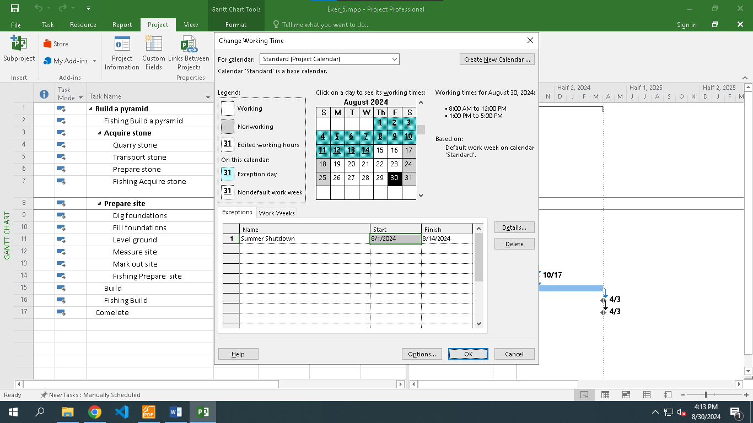

* **Display the Project Information**

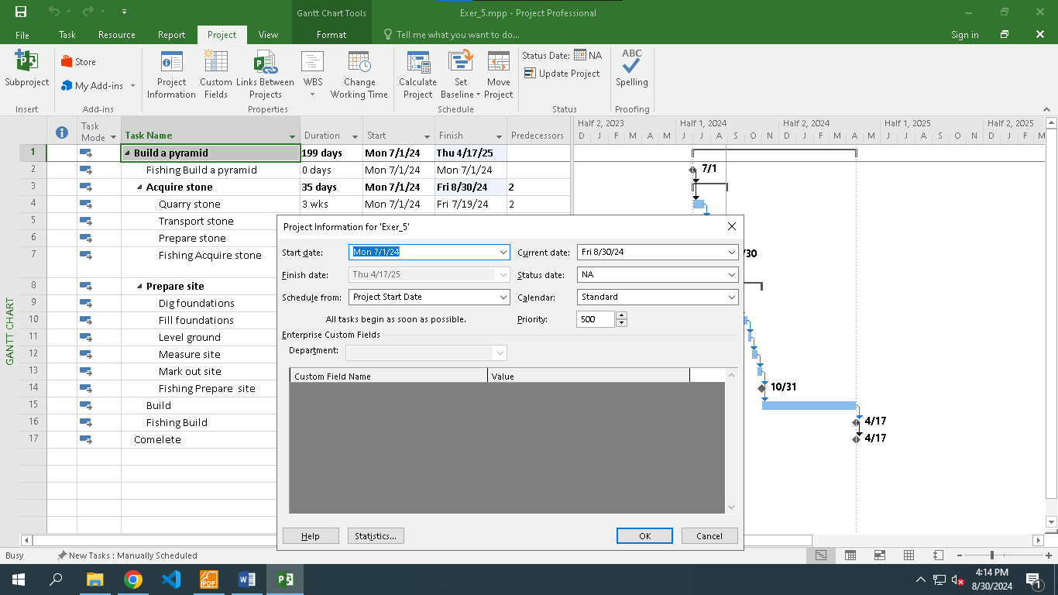

**Exercise 2. Changing Working Time**

* **Schedule it to start on 1 Dec 2024. The project will be based upon the Standard calendar**

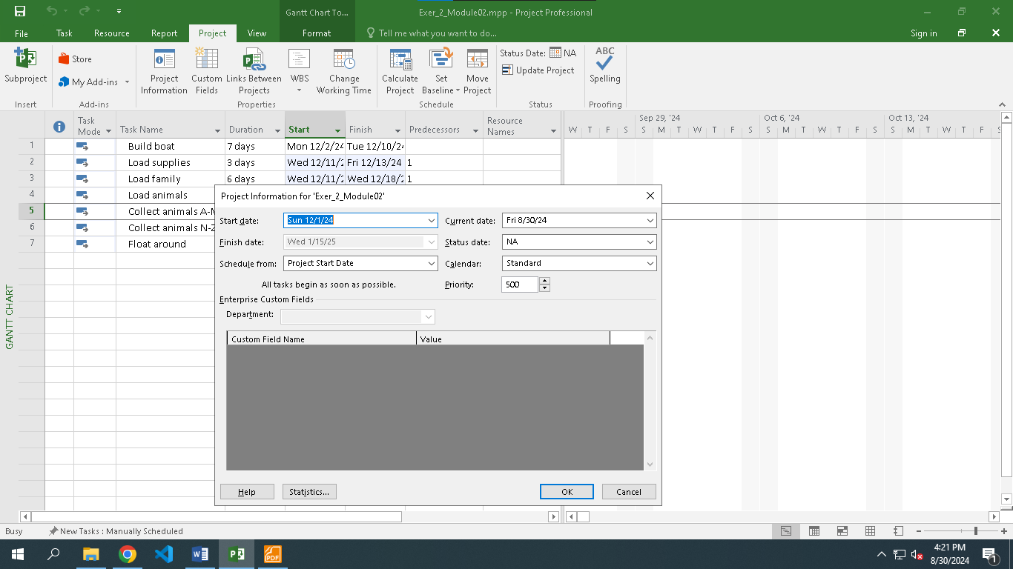

* **Go to the Change Working Time dialog box and create an Exception to the Standard calendar**

**called "Xmas Bank Holidays". This needs to make 25 and 26 December 2024 into nonworking**

**time.**

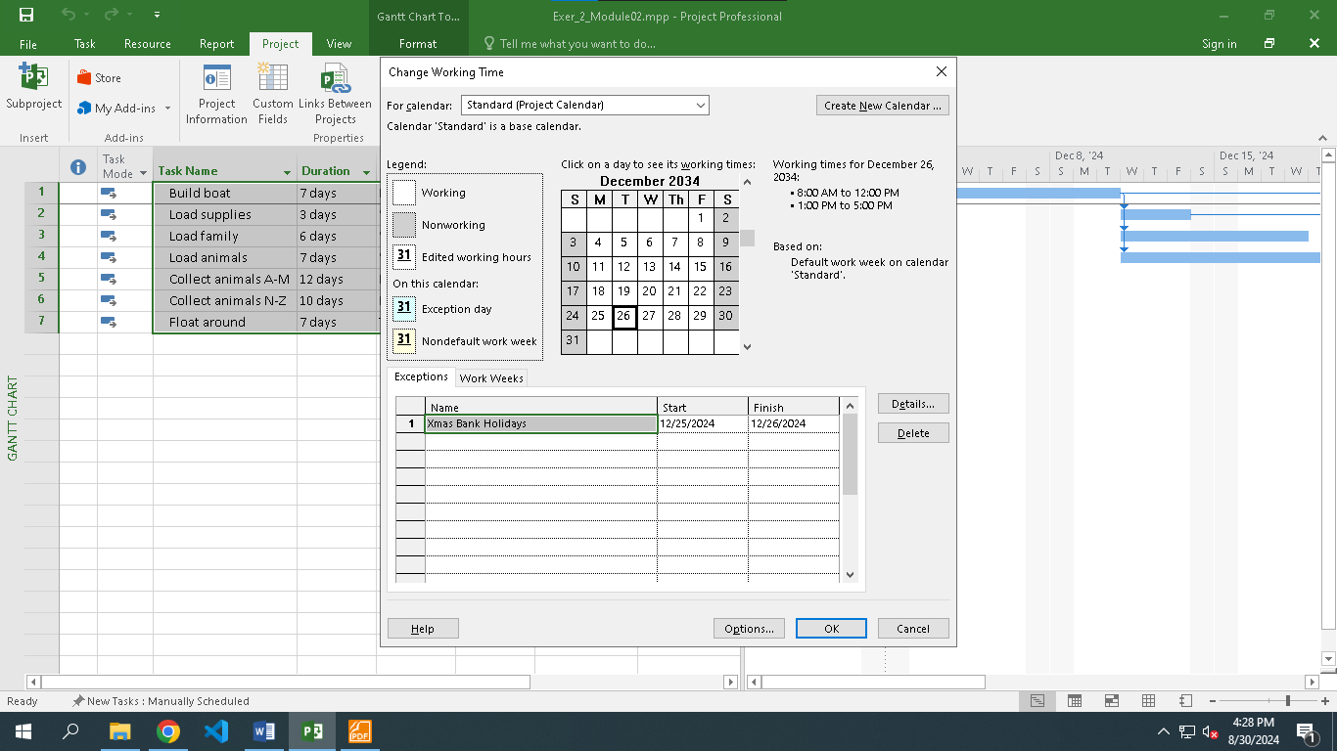

* **Use the Work Weeks tab to change the Standard calendar's default working week. This**

**project's standard working time is:**

* + 08:30 to 17:30 Monday to Thursday (no lunch break)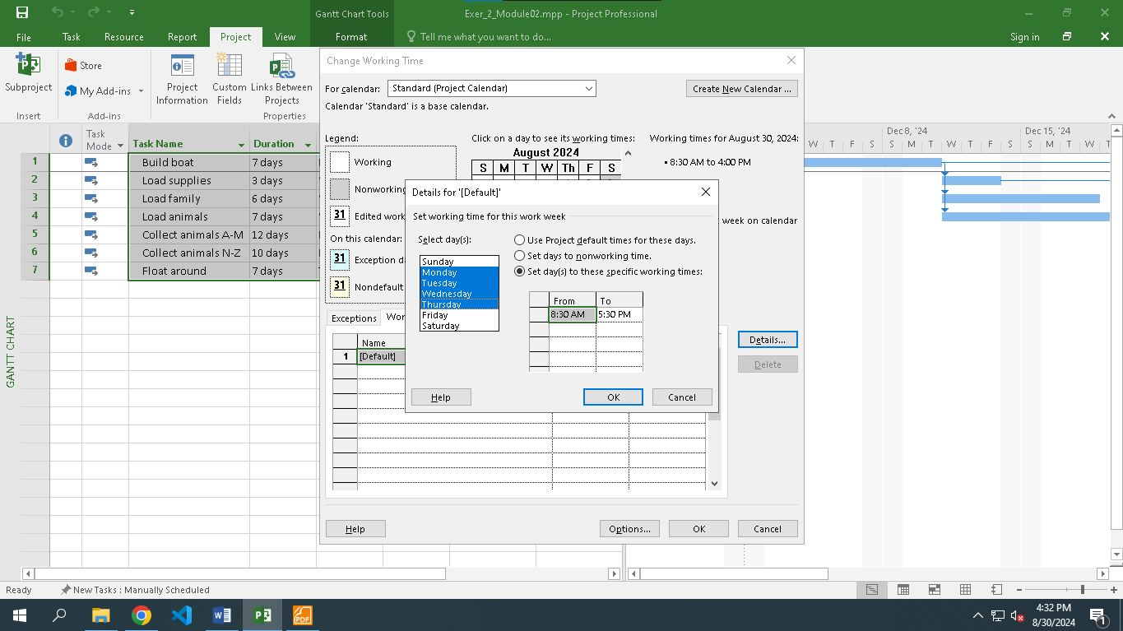
  + 08:30 to 16:00 on Fridays (no lunch break)

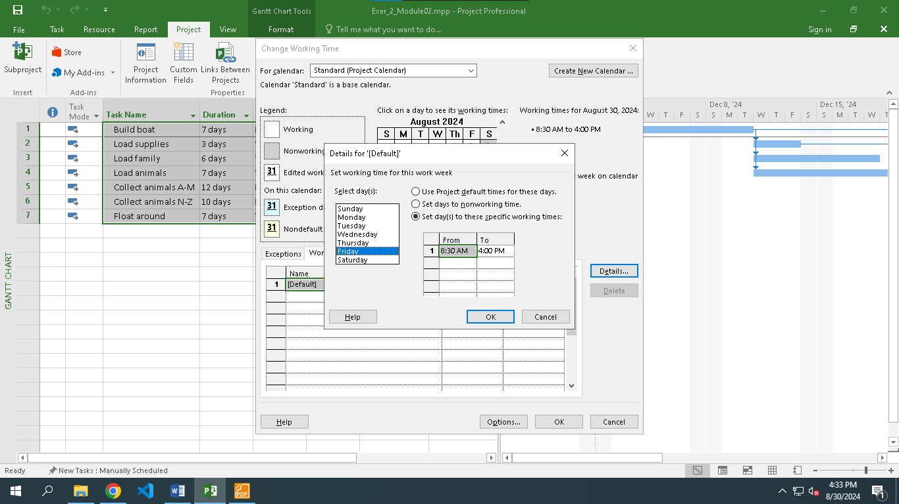

* + Add a new Work Week to the Standard calendar named "Xmas Slowdown". Use this to model a 12:30 finish on every weekday from 15 to 31 December 2024.

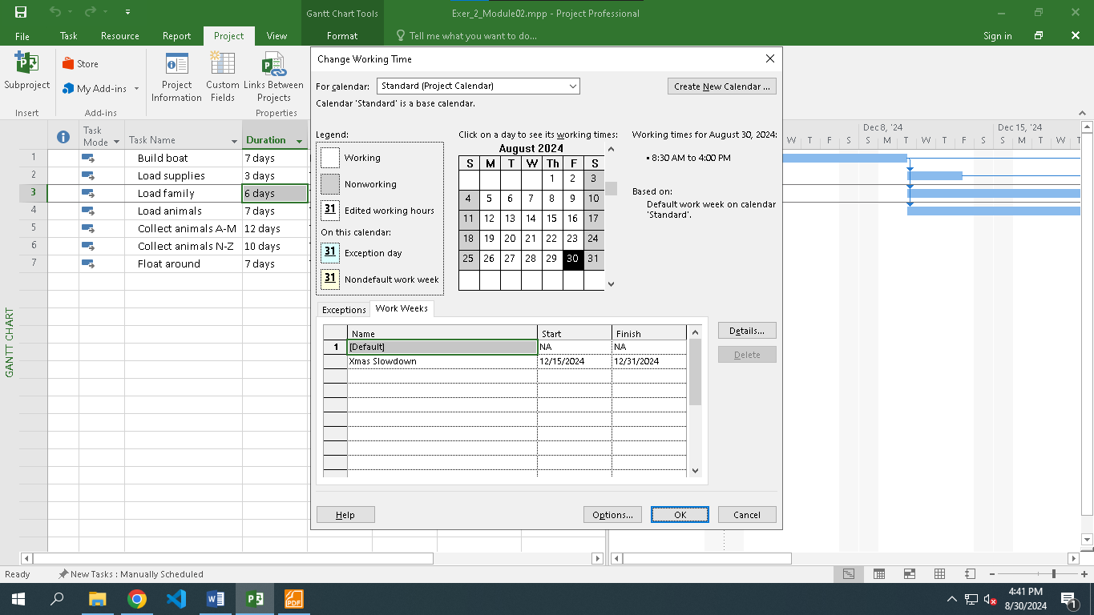

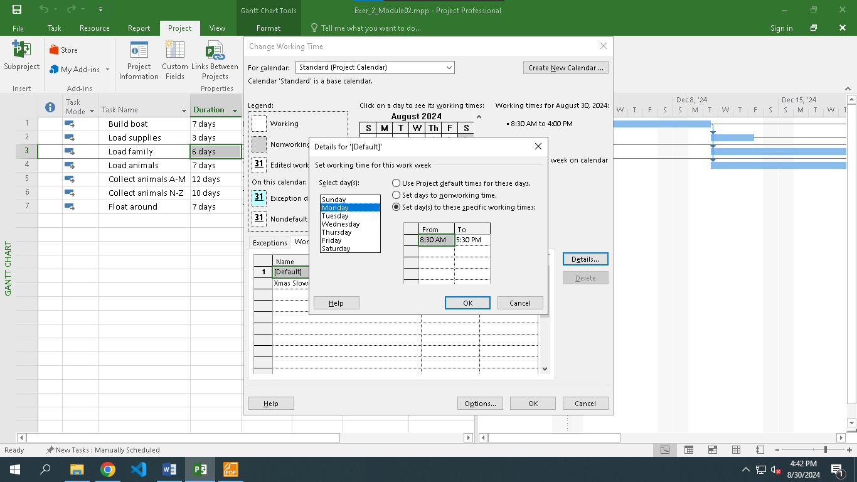

* **Display the Project Information.**

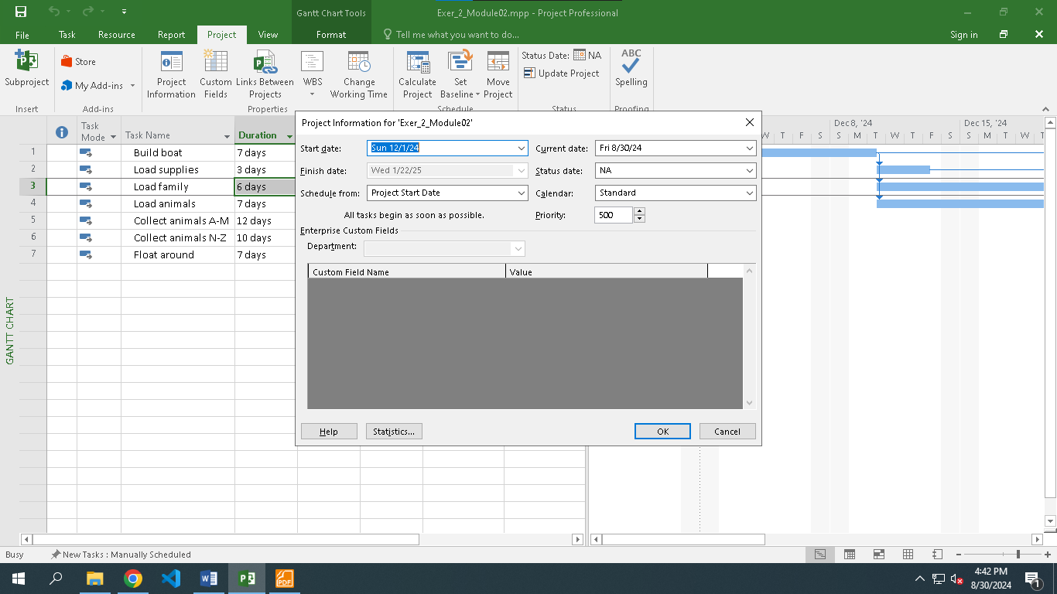

**Exercise 3. Part Time - creating new calendar**

* **Schedule it to start on 11 May 2024. This project should be based upon the Standard calendar.**

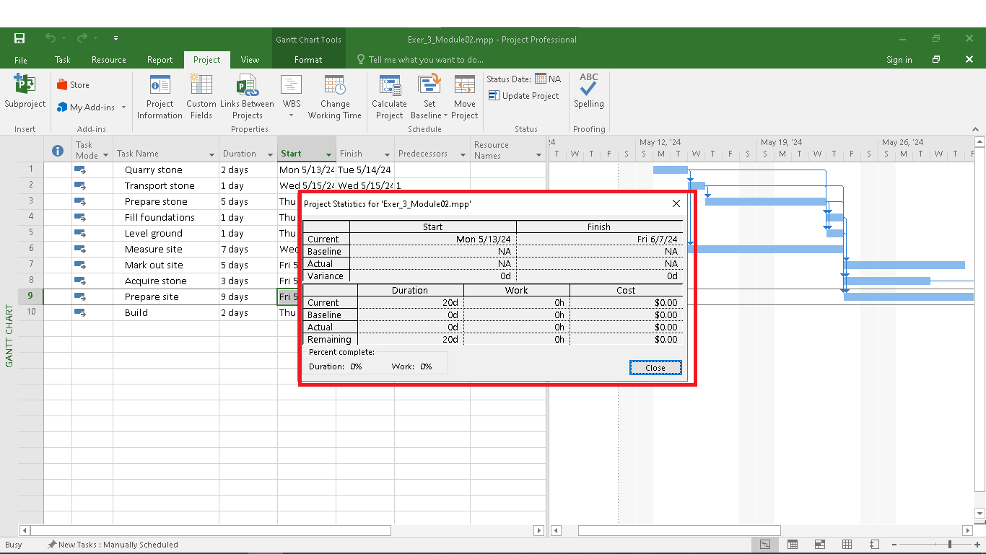

* **A part-time worker will be used on this project. Go to the Change Working Time dialog box**

**and create a new copy of the Standard calendar, calling it "Part Timer".**

* **Update the working time of your new calendar so that:**
  + **Mondays to Fridays are nonworking time**

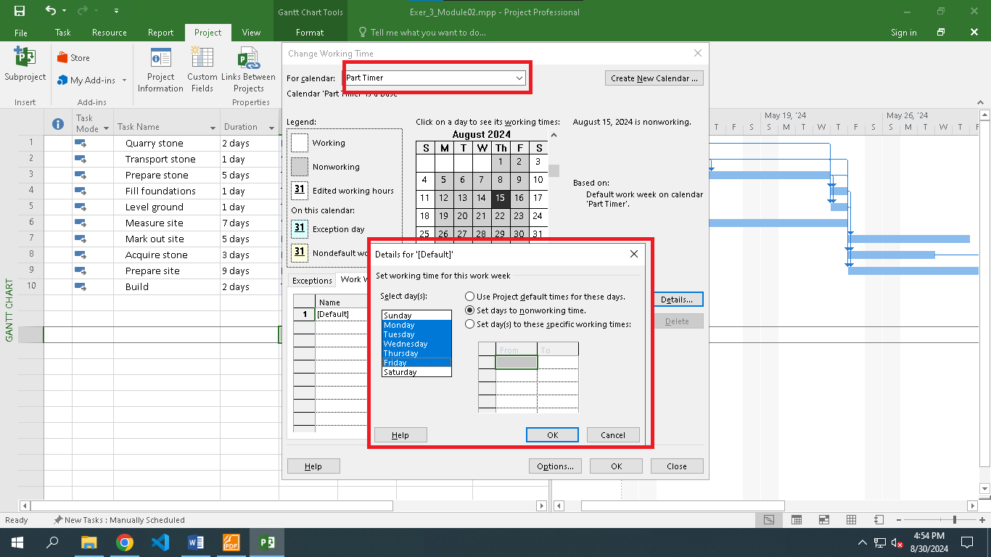

* + **The remaining 2 weekdays have working time of 10:00 to 15:00 (with no breaks)**

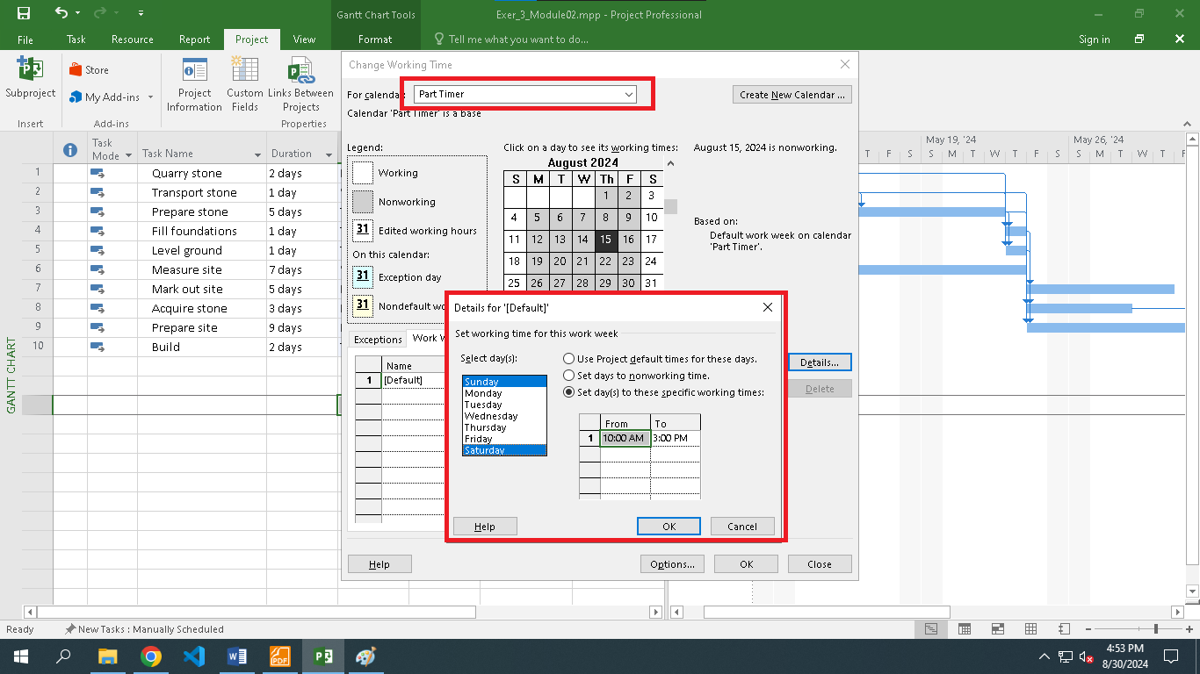

* **The part timer has also booked a holiday to US from 2 to 11 September. Create an Exception to their calendar with a sensible name and model these days as nonworking**

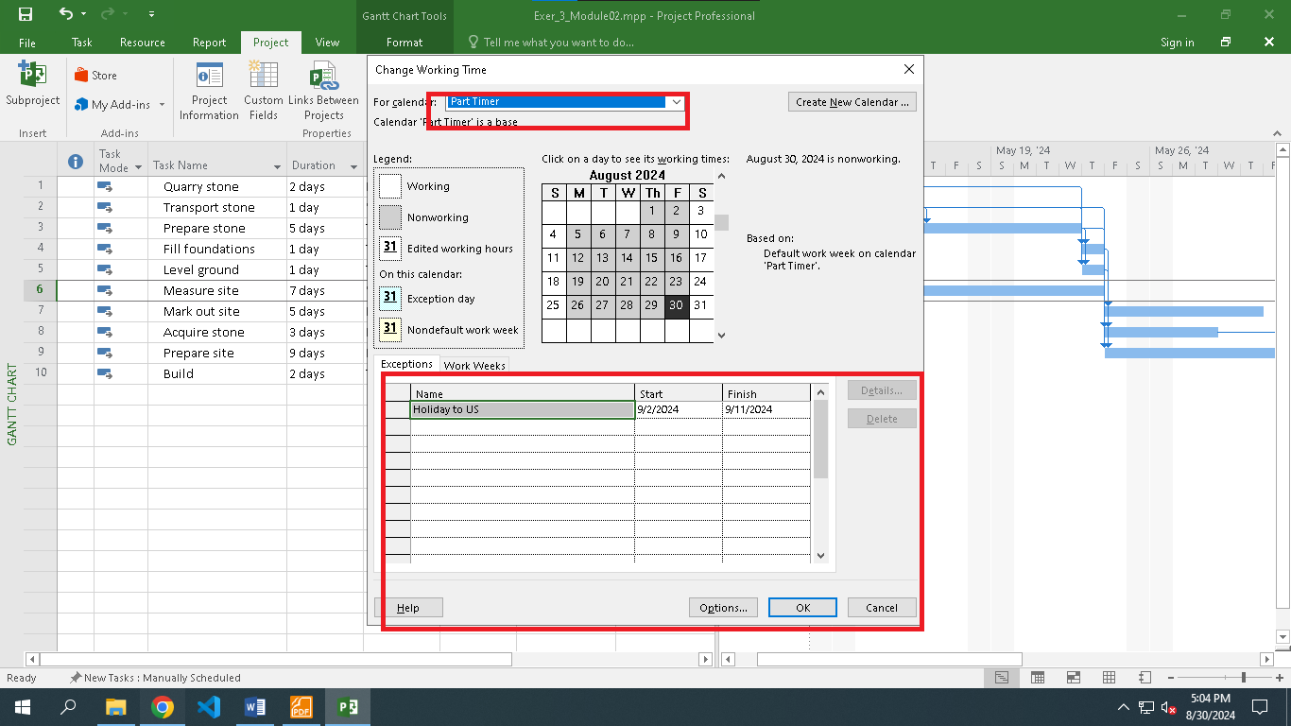

* **Although the overall project will be based upon the Standard calendar (as per the Project**

**Information dialog box), feel free to format the Gantt Chart to show the nonworking time for**

**new Part Timer calendar.**

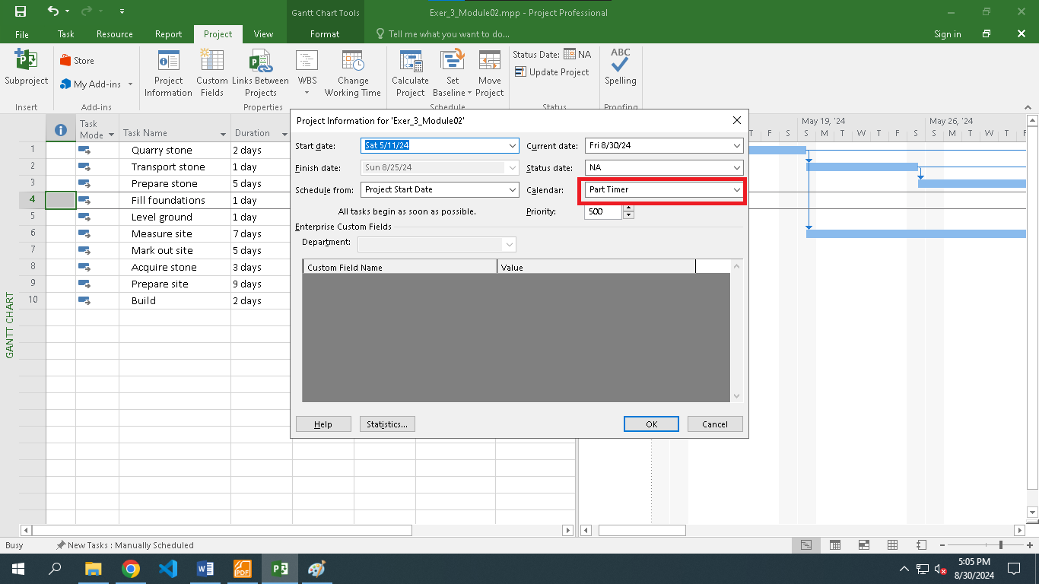

**Display the Project Information.**

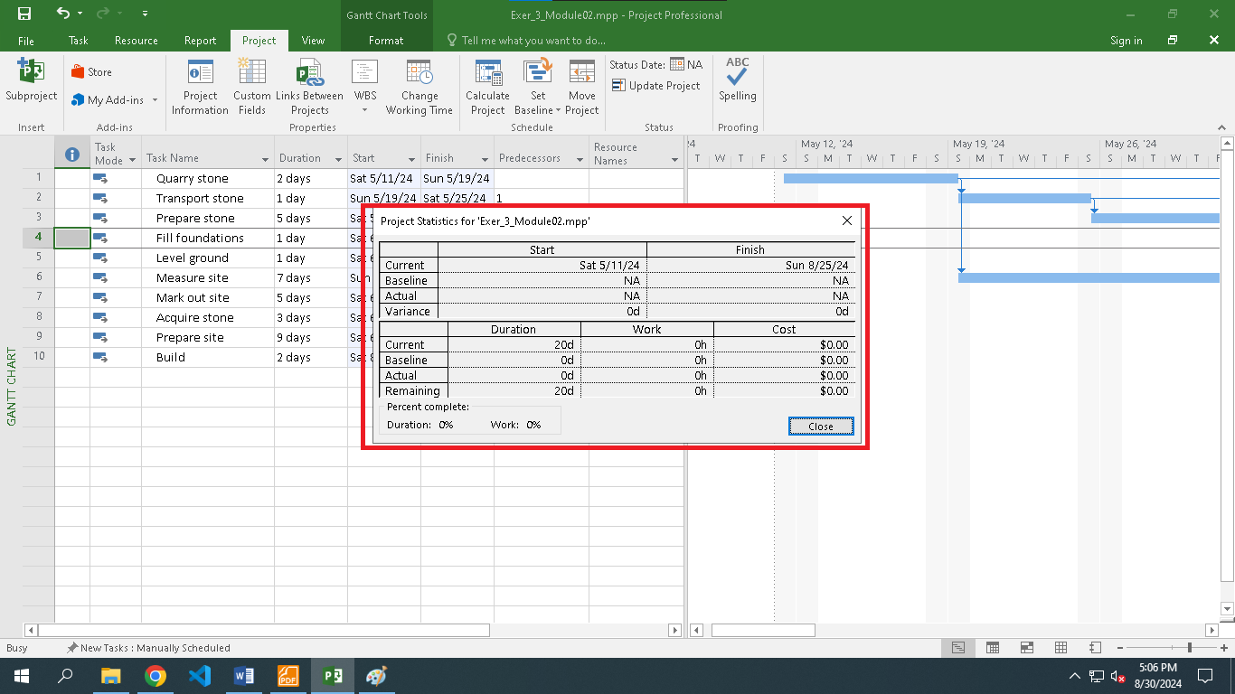

**Exercise 4. Changing Working Time**

* **Open project file Ex6 (Module 1), Use the Project Information dialog box to schedule it to start on Nov 1st of next year.**

* **Modify the Standard calendar and change the [Default] work week to use the hours shown below:**

* **Add an exception in the Standard calendar called Recovery. This exception should make December 26th to 31st non-working days.**

* **Display the Project Information.**

**Exercise 5. Create the private Time for a project**

* **Schedule this project to begin on January 1st of next year.**

* **Create the new Time Work for your project. [NameTimeProject]**

* + Monday to Friday: 7:30-11:30, 13:30-16:30

* + Saturday: 7:30-11:30

* **NameTimeProject have two important religious holidays when they don't work (Exception)**
  + Calendar 1 - on the last Monday (off 13:00-16:00) of every month. ****

* + Holiday Day - on April 30th, and May 1st in this year.

* **Assign the NameTimeProject to your Project and display the Project Information.**

**Exercise 6. Your project**

* **Create your plan from Monday to Sunday. It will list all of your activities, your time you spend and resources joining in each task.**

* **Create a new calendar called Student based on the Standard calendar.**
* **Change the [Default] work week so that the hours match to your calendar everyday**

* **Using Note function in MP 2010 to take note for important tasks in your plan.**

